ADITYA REDDY VELKUR
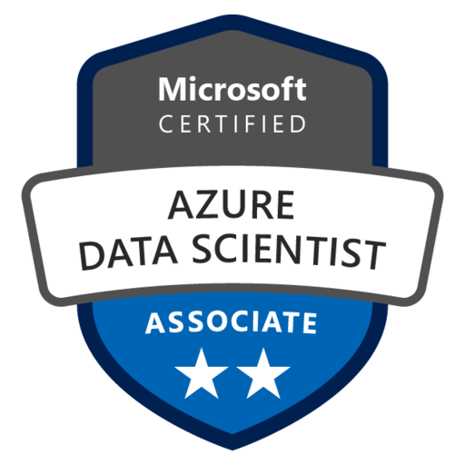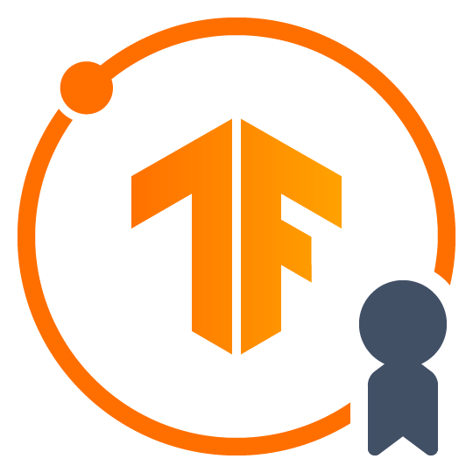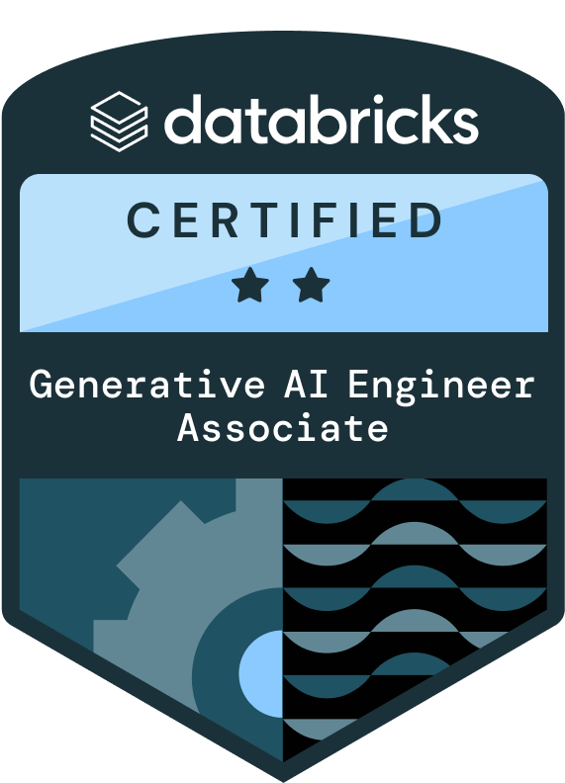

Senior AI/ML Engineer
Phone: 4694649269
E-Mail: velkuraditya@gmail.com
LinkedIn: https://www.linkedin.com/in/aditya-reddy-824983240/

Professional Summary:
- Senior AI/ML Engineer professional with 12+ years of experience delivering end-to-end data, machine learning, and Generative AI solutions, spanning analytics, predictive modeling, NLP, deep learning, and production-grade AI platforms across large enterprise environments.
- Demonstrated ability to design data science solutions that span structured, semi-structured, and unstructured data, enabling insight generation, automation, and intelligent decision-making at scale.
- Extensive experience translating business objectives into measurable data science outcomes, owning the full lifecycle from problem definition and data strategy to deployment and long-term optimization.
- Architected and delivered production-grade Generative AI platforms using Retrieval-Augmented Generation (RAG), Agentic AI, and Graph-based reasoning to power enterprise knowledge assistants and intelligent automation systems.
- Designed and implemented Graph RAG architectures to extract structured intelligence from unstructured documents, enabling explainable, traceable, and source-grounded responses for regulated enterprise environments.
- Built autonomous and semi-autonomous agentic AI systems leveraging Chain-of-Thought (CoT), Tree-of-Thought (ToT), and tool-calling patterns to automate multi-step business workflows.
- Led fine-tuning and adaptation of large language models using LoRA and PEFT, balancing inference cost, latency, and domain relevance for real-world production use cases.
- Designed AI-driven systems that combine predictive models, generative reasoning, and rule-based logic to support decision automation, document intelligence, and conversational interfaces.
- Delivered secure, scalable AI applications integrated with enterprise systems, enabling seamless interaction across chat, web, and workflow platforms.
- Strong experience designing AI solutions with an emphasis on governance, explainability, and reliability, ensuring adoption in regulated and risk-sensitive domains.
- Led full-cycle machine learning initiatives covering feature engineering, model selection, training, validation, deployment, and monitoring across multiple business domains.
- Applied supervised, unsupervised, and ensemble learning techniques for classification, regression, clustering, anomaly detection, and forecasting problems.
- Deep experience in model evaluation and statistical validation using metrics such as ROC-AUC, precision/recall, cross-validation, and hypothesis testing to ensure robust, defensible results.
- Designed scalable ML pipelines that support experimentation, reproducibility, and continuous improvement in enterprise environments.
- Built advanced NLP pipelines for document classification, semantic search, summarization, entity extraction, and conversational understanding across large document repositories.
- Extensive hands-on experience with transformer-based NLP architectures, embeddings, and hybrid retrieval strategies combining semantic and keyword-based search.
- Designed NLP solutions that bridge structured enterprise data with unstructured text, enabling contextual reasoning and high-precision information retrieval.
- Strong foundation in deep learning architectures including CNNs, RNNs, LSTMs, Autoencoders, and GANs for text, image, and time-series use cases.
- Delivered deep learning solutions for tasks such as anomaly detection, sequence modeling, recommendation systems, and representation learning.
- Balanced deep learning approaches with classical ML techniques to meet real-world constraints around explainability, data volume, and operational cost.
- Expert-level Python developer with extensive experience building data, ML, and AI systems using PyTorch, TensorFlow, Keras, Scikit-learn, Pandas, NumPy, and SciPy.
- Built high-performance APIs and backend services using FastAPI and Flask to serve ML and GenAI models in real-time, production environments.
- Leveraged visualization and analysis libraries such as Matplotlib, Seaborn, and Plotly to support exploratory analysis and model diagnostics.
- Strong background in data engineering fundamentals including ETL pipeline design, dimensional modeling, OLAP/OLTP systems, and large-scale data processing using Spark ecosystems.
- Hands-on experience across Big Data and distributed systems, enabling efficient processing and analysis of high-volume, high-velocity datasets.
- Proficient in data visualization and executive reporting using Tableau, Power BI, QuickSight, and R Shiny to translate complex analytics into actionable insights.
- Proven leader of cross-functional teams in Agile/Scrum environments, guiding projects from concept through delivery while mentoring engineers and data scientists.
- Recognized for bridging business and technology, combining strong communication skills with deep technical expertise to deliver practical, high-impact AI and data solutions.

Technical Skills:
- Programming & Development Languages: Python, Java, JavaScript, R, C++, SQL, HTML, CSS, Scala, ReactJS, Next.js, Angular, jQuery, REST APIs, Postman, Swagger
- Machine Learning & Predictive Analytics: Scikit-learn, XGBoost, LightGBM, Random Forest, Gradient Boosting, SVM, KNN, Naive Bayes, Logistic Regression, Linear Regression, Decision Trees, Classification Algorithms, Clustering (K-Means, Hierarchical), Dimensionality Reduction (PCA, t-SNE), Feature Engineering, Hyperparameter Tuning, Cross-Validation, Model Evaluation, Ensemble Methods, SHAP, LIME, Recommendation Systems
- Deep Learning & Neural Networks: TensorFlow, PyTorch, Keras, CNN, RNN, LSTM, Bi-LSTM, GRU, Transfer Learning (VGG, ResNet), Attention Mechanism, Object Detection (YOLO, Faster R-CNN), Image Segmentation (U-Net, Mask R-CNN), OCR, Autoencoders, GANs, VAEs, Optimization Algorithms (Adam, SGD), Regularization (Dropout, Batch Normalization)
- Generative AI & Large Language Models: LangChain, Lang Smith, GPT, BERT, T5, LLMs, RAG (Retrieval-Augmented Generation), Prompt Engineering, Fine-tuning (LoRA, QLoRA), Vector Databases (FAISS, Pinecone, Chroma), Embedding Models, Hugging Face, Ollama, Agentic AI, Diffusion Models, Text-to-Image Generation, Chatbots, AI Search Engines, Zero-Shot Learning
- MLOps & Model Operations: MLflow, Airflow, Kubeflow, Docker, Kubernetes, Model Deployment, Model Monitoring, Model Versioning, CI/CD for ML, Experiment Tracking, Weights & Biases, Feature Stores (Feast), TruLens, Prompt Layer, vLLM, TGI, Data Versioning (DVC), Prometheus, Grafana
- Big Data & Distributed Computing: Hadoop, Apache Spark, Hive, HBase, Pig, Sqoop, Kafka, Kinesis, Scala, MapReduce, Distributed Data Processing
- Database Systems & Storage: MySQL, PostgreSQL, MongoDB, SQLite, Microsoft SQL Server, Redshift, DynamoDB, Teradata, SQL Alchemy, Neo4j (Graph DB), Vector Databases (FAISS, Pinecone), RDS
- Cloud Platforms:
- AWS: EC2, Lambda, SageMaker, Bedrock, EMR, S3, Glue, Kinesis, Quick Sight, API Gateway, Athena, Recognition, DynamoDB, CloudFormation, CloudWatch, IAM
- Azure: Data Factory, Databricks, Synapse Analytics, Blob Storage, Data Lake Storage, Event Hubs, Logic Apps, Functions, Stream Analytics, Monitoring
- GCP: Vertex AI, AI Platform, BigQuery
- Development Tools & Environment: Git, GitHub, GitLab, Docker, VS Code, Jupyter Notebook, Google Colab, CUDA Toolkit, Linux/Unix, Bash Scripting, Conda

Education Details:
- Masters: University of Texas at Arlington,2014 Computer science
- Bachelors: Visveswaraya Technological University,2012 Computer Science

Certifications:
- Azure Data Scientist
- Databricks certified GenAI Engineer Associate
- Tensor Flow

Professional Experience:
Goosehead Insurance, Dallas, TX(Remote) Nov 2023 – Present
Sr AI/ML Engineer
Responsibilities:
- Developed AI agents similar to a “virtual finance team”, automating transaction categorization, receipt matching, anomaly detection, and exception flagging for downstream review.
Built ML models to categorize financial transactions with high accuracy, detect inconsistencies, and surface actionable insights for operations and finance stakeholders.
- Designed GenAI workflows to convert unstructured inputs (emails, scanned documents, handwritten notes, PDFs).
Implemented AI-driven automation to draft personalized notifications and reminders, improving customer engagement response times.
Optimized training and inference pipelines using GPU acceleration, model quantization, batching, and parameter-efficient fine-tuning (LoRA/PEFT) to reduce latency and infrastructure cost.
Deployed scalable and responsible AI solutions on AWS, Azure, and GCP, ensuring governance, observability, and compliance with enterprise standards. Built scalable document intelligence pipelines leveraging vector databases hosted on cloud infrastructure to enable semantic search, summarization, and question answering over millions of documents.
- Implemented fine-tuning strategies using LoRA and PEFT techniques to adapt foundation models for domain-specific language understanding, reducing inference cost while improving response relevance and accuracy.
- Developed high-performance backend services using Golang (Go) to support scalable GenAI and ML inference workloads with low latency and high throughput.
- Integrated GoIntuit Assist–style intelligent assistant capabilities to automate financial workflows such as transaction categorization, document understanding, and anomaly detection.
- Designed and implemented GenOS-based Generative AI pipelines, enabling orchestration of LLMs, RAG workflows, and agentic AI systems in production environments
- Built secure service components and internal APIs using C# and Go, enabling seamless integration between AI services and enterprise systems.
- Integrated conversational AI interfaces using cloud bot frameworks, enabling seamless interaction across web and collaboration platforms while routing advanced AI queries to backend LLM services.
- Developed and deployed supervised and unsupervised machine learning models including regression, classification, clustering, and dimensionality reduction techniques to solve real-world prediction and segmentation problems.
- Applied algorithms such as Random Forest, XGBoost, SVM, KNN, Naive Bayes, and PCA to model customer behavior, operational risk, and event impact using large-scale cloud-hosted datasets.
- Conducted rigorous model evaluation using cross-validation, hyperparameter tuning, and performance metrics to ensure robustness, fairness, and generalization before production deployment on AWS.
- Built explainable ML solutions using feature importance and model interpretation techniques to improve transparency and stakeholder trust in automated decision-making systems.
- Designed and implemented end-to-end MLOps pipelines using AWS SageMaker Pipelines, enabling automated training, validation, versioning, and deployment of machine learning models.
- Integrated AWS Lambda, Step Functions, and CI/CD pipelines to orchestrate scalable model workflows, ensuring rapid experimentation and reliable promotion of models to production.
- Implemented continuous model monitoring using SageMaker Model Monitor and CloudWatch to detect data drift, performance degradation, and operational anomalies in real time.
- Containerized ML services using Docker and deployed them on AWS EC2 and Kubernetes-compatible environments to ensure portability, scalability, and reproducibility.
- Designed and implemented advanced NLP pipelines for text classification, entity extraction, semantic search, and intent detection using transformer-based models and cloud AI services.
- Leveraged AWS Transcribe and cloud-based speech-to-text services to convert audio data into structured text, followed by NLP preprocessing including tokenization, lemmatization, and contextual embedding generation.
- Built hybrid NLP search systems combining keyword-based retrieval with vector similarity search to significantly improve document discovery accuracy and relevance.
- Developed deep learning models using CNNs, RNNs, and LSTM architectures to solve anomaly detection, time-series forecasting, and sequential prediction problems.
- Architected enterprise-scale GenAI platforms using Golang to orchestrate LLM inference, RAG pipelines, and agent-based workflows with high concurrency and fault tolerance.
- Designed GenOS-based AI orchestration layers to manage prompt routing, tool calling, memory, and workflow state across multiple AI agents in production.
- Built financial AI assistants (GoIntuit Assist–style) to automate transaction classification, document intelligence, anomaly detection, and finance operations decisioning.
- Developed low-latency backend services in Go for real-time AI inference, streaming responses, and asynchronous task execution.
- Implemented secure C# services for enterprise integration, authentication, authorization, and data exchange between AI systems and core business platforms.
- Led design of scalable microservices architecture supporting AI workloads, leveraging containerization, service discovery, and horizontal scaling.
- Optimized AI pipelines using parallel execution, batching, and async processing, improving system throughput and reducing response times significantly.
- Established production AI governance including logging, monitoring, traceability, and auditability for GenAI workflows in regulated environments.
- Built ETL and ELT pipelines integrating cloud data warehouses such as Snowflake and Redshift, ensuring scalable and reliable data transformation workflows.
- Developed interactive dashboards and executive reports using Power BI, Tableau, and Excel Services to communicate insights and KPIs to senior stakeholders.
- Collaborated closely with product managers, architects, and business stakeholders to translate requirements into scalable AI and data science solutions aligned with business objectives.
- Led technical design discussions, mentored junior data scientists, and established best practices for ML development, documentation, and production readiness.
- Played a key role in driving AI adoption across the organization by evangelizing data-driven decision-making, improving operational efficiency, and enabling innovation through cloud-based AI platforms.
Environment: Python, AWS SageMaker, S3, EC2, Lambda, Step Functions, CloudWatch, Redshift, EMR, Azure Azure AD, Bot Service, Generative AI, LangChain, LangGraph, RAG, Vector Databases, Machine Learning, Deep Learning, NLP, PyTorch, TensorFlow, Scikit-learn, Pandas, NumPy, SciPy, FastAPI, Flask, Docker, Snowflake, OLAP, OLTP, ODS, 3NF, Power BI, Tableau, SDLC
T-Mobile, Bellevue, WA Aug 2021 to Oct 2023
AI Engineer
Responsibilities:
- Designed and delivered an enterprise-grade AI and intelligent automation platform that unified natural language understanding, telemetry analytics, and predictive modeling to support real-time operational decision-making. The solution leveraged AWS and Azure cloud services to scale AI workloads, enable conversational interfaces, and process high-volume data streams reliably.
- Developed AI-driven systems that combined machine learning, NLP, and rule-based reasoning to automate troubleshooting, risk scoring, and anomaly detection across large-scale operational environments hosted on AWS and Azure.
- Architected intelligent virtual assistants capable of interpreting technical queries, reasoning over structured and unstructured data, and delivering contextual responses using cloud-native AI services.
- Built backend AI services using Golang for real-time intelligent assistants, ensuring efficient concurrency handling and optimized resource utilization.
- Implemented GenOS-aligned AI orchestration patterns to manage LLM workflows, embeddings, and hybrid retrieval pipelines for enterprise knowledge assistants.
- Developed intelligent automation components similar to GoIntuit Assist, enabling conversational AI to support operational decision-making and troubleshooting workflows.
- Used C# to develop supporting microservices and enterprise integrations for AI-driven platforms deployed across cloud environments.
- Developed backend services in Golang to support scalable ML inference and financial risk analytics pipelines.
- Designed early GenOS-style generative and predictive AI frameworks to combine ML models, NLP pipelines, and rule-based logic for financial decision automation.
- Implemented AI assistant capabilities similar to GoIntuit Assist to automate financial insights, reporting, and anomaly detection for risk and compliance teams.
- Built secure application components using C#, integrating ML services with enterprise banking systems and data platforms.
- Developed and trained deep learning models using TensorFlow and Keras for anomaly detection, pattern recognition, and classification tasks on structured and unstructured datasets.
- Applied neural network architectures to high-dimensional telemetry and time-series data, improving early detection of operational anomalies and failure patterns.
- Optimized deep learning training workflows using distributed compute and GPU-enabled cloud instances to reduce training time and support rapid experimentation.
- Built and fine-tuned transformer-based models for multi-label document classification using Hugging Face Transformers and LLaMA, adapting models to domain-specific language.
- Applied parameter-efficient fine-tuning techniques such as LoRA and PEFT to reduce training cost while maintaining high model accuracy in production environments.
- Integrated LLM workflows with LangChain and cloud-based embedding services to support hybrid retrieval and contextual reasoning across large knowledge bases.
- Conducted large-scale data analysis, validation, cleansing, and imputation using Pandas, NumPy, and SciPy to ensure data integrity for downstream AI models.
- Built machine learning pipelines using Scikit-learn for feature engineering, model training, evaluation, and hyperparameter optimization.
- Leveraged PySpark and MLlib for distributed data processing, feature selection, and scalable model training on cloud-hosted Spark clusters.
- Designed object-centric and ontology-based data models that mapped raw telemetry to physical asset entities, improving root cause analysis efficiency by over 40%.
- Developed containerized Flask-based microservices and deployed them using Docker on cloud infrastructure for scalable and reliable ML inference.
- Built and optimized data warehouse schemas including Star and Snowflake models to support analytical workloads and operational dashboards.
- Implemented cloud monitoring and observability using AWS CloudWatch, Google Cloud Monitoring, and QuickSight to track system health and model performance.
- Served as a technical lead for intelligent assistant development, coordinating AI design, development, and deployment across distributed engineering teams.
- Collaborated closely with product managers, network engineers, and stakeholders to translate operational challenges into scalable AI and NLP solutions.
- Actively contributed to Agile delivery processes by mentoring team members, participating in sprint planning, and ensuring timely, high-quality AI solution delivery.
Environment: Python, Artificial Intelligence, NLP, Deep Learning, Large Language Models, AWS EC2, S3, Lambda, Redshift, DynamoDB, SageMaker, CloudWatch), Azure Bot Framework, Azure AI Language, Functions, Vertex AI, Vector Search, Hugging Face, LangChain, TensorFlow, Keras, Scikit-learn, PySpark, Pandas, NumPy, SciPy, NLTK, SpaCy, XGBoost, Docker, Flask, Snowflake, OLAP, OLTP, Power BI, SDLC
Fifth third Bank, Tampa FL April 2020 to July 2021
Machine Learning Engineer
Responsibilities:
- Built an end-to-end Machine Learning platform for financial risk, sentiment, and decision analytics, enabling automated credit scoring, document intelligence, and customer insight generation. The solution integrated AWS-based data pipelines, feature engineering workflows, and supervised/unsupervised ML models deployed into production environments.
- Designed and implemented end-to-end supervised learning pipelines for credit risk scoring and predictive analytics, using algorithms such as XGBoost, Random Forest, SVM, and Logistic Regression on AWS-hosted datasets.
- Applied unsupervised learning techniques including K-Means clustering and PCA to identify hidden patterns, customer segments, and anomaly behaviors within large transactional and behavioral datasets stored in AWS S3 and Snowflake.
- Developed specialized AI agents for financial risk, compliance, and transaction monitoring, aligning with accounting, payments, and finance workflows.
• Built ML models to predict payment risks, flag potential compliance issues, and generate real-time financial summaries and KPIs.
• Designed AI systems to assist finance teams by automating data validation, anomaly detection, and reporting workflows. Tuned hyperparameters using grid search and cross-validation techniques to optimize model performance while balancing bias-variance tradeoffs.
- Developed NLP pipelines for text classification and sentiment analysis on unstructured and semi-structured data such as documents, customer feedback, and financial notes.
- Implemented text preprocessing workflows including tokenization, stop-word removal, stemming, lemmatization, and TF-IDF vectorization using NLTK and Scikit-learn.
- Built hybrid text-based ML models combining structured features and textual signals to enhance predictive power in sentiment and risk classification tasks.
- Designed semantic and keyword-based search strategies to improve document retrieval efficiency from SQL databases and SharePoint-based repositories.
- Evaluated deep learning feasibility versus classical ML models, selecting optimal approaches based on dataset size, explainability requirements, and infrastructure constraints.
- Conducted large-scale data analysis, cleansing, and imputation using Pandas, NumPy, and SciPy to ensure high-quality, model-ready datasets.
- Used Matplotlib and Seaborn to perform exploratory data analysis (EDA), visualize feature distributions, correlations, and model performance metrics.
- Built modular ML codebases in Python with Scikit-learn, enabling reproducibility, versioning, and easier handoff to deployment teams.
- Collaborated with data engineering teams to design and implement ETL pipelines using Snowflake, AWS S3, and AWS RDS, automating ingestion and transformation of structured data.
- Designed OLTP and OLAP data models using Star and Snowflake schemas, and created logical and physical data models using Erwin for analytics-ready storage.
- Developed RESTful APIs and web-based data applications using Flask, enabling real-time access to ML predictions and analytical insights.
- Automated model packaging and deployment using Docker, and deployed trained models to AWS SageMaker with CI/CD pipelines for versioned releases.
- Implemented granular data governance, row-level security, and Purpose-Based Access Control (PBAC) within SQL Server and AWS-backed systems to meet regulatory compliance requirements.
- Actively participated in Agile ceremonies including sprint planning, grooming, reviews, and daily stand-ups to ensure timely delivery of ML features.
- Collaborated with business analysts, compliance teams, and stakeholders to translate regulatory and analytical requirements into scalable ML solutions while reducing project cost and risk.
Environment: Machine Learning, Python, Scikit-learn, Feature Engineering, Supervised Learning, Unsupervised Learning, AWS S3, RDS, SageMaker, Pandas, NumPy, SciPy, XGBoost, Random Forest, SVM, K-Means, PCA, NLTK, Matplotlib, Seaborn, Flask, Docker, Snowflake, OLAP, OLTP, SQL, Power BI, Power Query, ETL, Erwin, APIs, SDLC
CareFirst BCBS, VA Sep 2018 to March 2020
Data Analyst
Responsibilities:
- Supported enterprise data analytics and reporting initiatives focused on customer profiling, segmentation, and pricing analysis, working with large structured datasets migrated from legacy systems into cloud-enabled analytical environments on AWS for improved accessibility and reporting performance.
- Performed extensive data cleaning, transformation, validation, and normalization on multi-domain datasets, ensuring high data quality and consistency prior to downstream analytics and reporting workflows.
- Built reusable Python scripts to handle missing values, outlier detection, data imputation, and format standardization using Pandas and NumPy, significantly reducing manual data preparation effort.
- Developed multivariate data validation checks for equity, derivative, currency, and commodity datasets, improving data pipeline reliability and increasing processing efficiency by approximately 17%.
- Designed and delivered interactive dashboards and KPI reports using Tableau and Advanced Microsoft Excel, enabling business users to explore trends, performance metrics, and customer behavior insights.
- Published live Tableau dashboards and reports to Tableau Server, managing extracts, refresh schedules, and user access to support enterprise-wide self-service analytics.
- Wrote complex ad-hoc SQL queries using joins, subqueries, and transformations to extract and analyze data from Oracle and SQL Server databases, supporting operational and analytical reporting needs.
- Worked extensively with OLTP and OLAP systems, validating source-to-target mappings and ensuring data accuracy across transactional and analytical data stores.
- Automated repetitive data analysis and reporting tasks using Python scripts, improving turnaround time for weekly, monthly, and quarterly reporting cycles.
- Assisted in designing and optimizing ETL workflows using Alteryx and Snowflake, including performance tuning for data loads migrated to AWS-backed environments.
- Provided Git repository support including version control, access management, and repository maintenance, while collaborating closely with cross-functional teams to meet competing delivery priorities.
Environment: Data Analysis, Python, Pandas, NumPy, SQL, Tableau, Data Cleaning, Data Visualization, AWS, Snowflake, Alteryx, Matplotlib, Seaborn, SciPy, ETL, Oracle, SQL Server, OLAP, OLTP, ER Studio, Tableau Server, Git, Advanced Excel, Hadoop, MongoDB, JavaScript, HTML, NodeJS, SDLC
Keurig, TX June 2016 to Aug 2018
Role: Data Analyst
Responsibilities
- Supported healthcare analytics and reporting initiatives by transforming raw claims, membership, and clinical data into structured, analytics-ready datasets, enabling business users and product teams to make informed decisions through Tableau dashboards and cloud-hosted data environments on AWS.
- Performed extensive data cleaning, validation, and standardization on healthcare datasets including medical claims, pharmacy records, and membership files, ensuring accuracy and consistency across reporting layers.
- Developed data hygiene and validation programs using SQL, SAS, and Python to detect missing values, duplicates, and inconsistencies prior to dashboard development and recurring analytical reporting.
- Designed and developed interactive Tableau dashboards and workbooks by converting high-level business requirements into detailed technical and functional specifications, collaborating closely with stakeholders throughout the development lifecycle.
- Created advanced Tableau visualizations including bar charts, line charts, treemaps, bubble charts, waterfall charts, funnels, and trend-based views to support operational, clinical, and executive reporting needs.
- Automated recurring reports and dashboards in Tableau, optimizing data extracts, refresh schedules, and published content on Tableau Server to significantly improve reporting turnaround time.
- Built custom SQL queries and data sources using joins, data blending, filters, and transformations to consolidate data from multiple systems such as claims, pharmacy, lab, and radiology sources.
- Utilized Python libraries such as Pandas and NumPy for exploratory data analysis, aggregation, and ad-hoc reporting, supporting deeper investigation of healthcare trends and utilization metrics.
- Designed and maintained metadata layers in Tableau by managing dimensions, measures, calculated fields, and data source definitions, ensuring consistency across dashboards and reports.
- artnered with business users, healthcare domain experts, and product teams to gather requirements, provide subject-matter support, and prioritize reporting deliverables in a fast-paced, cross-functional environment.
Environment: Data Analysis, Tableau, SQL, Data Cleaning, Data Visualization, Python, Pandas, NumPy, SAS, AWS, Hive, Pig, R Programming, Tableau Server, MS Excel, MS Office, Windows
Techzio Solutions LLC, Dallas TX Feb 2014 to May 2016
Role: Data Analyst.
Responsibilities
- Supported large-scale operational and reporting initiatives by transforming raw network and sales data into structured, analysis-ready datasets, enabling performance monitoring, KPI tracking, and business reporting through SQL-driven analytics and Tableau dashboards.
- Performed extensive data cleaning, validation, and transformation across multiple datasets by defining cleanup rules, correcting inconsistencies, and standardizing formats to ensure accuracy and reliability of analytical outputs.
- Web-scraped, cleansed, and reconciled over 40 sales and operational datasets using Python, resolving nearly 90% of data discrepancies and improving overall data consistency for reporting use cases.
- Designed and delivered interactive Tableau dashboards to visualize key performance indicators, trends, and operational metrics, enabling stakeholders to monitor network efficiency and business performance.
- Developed and optimized 200+ SQL stored procedures, views, and ad-hoc reports using MS SQL Server, significantly improving query performance and supporting recurring reporting requirements.
- Extracted and correlated network traffic metrics and event data using complex T-SQL queries, enabling deeper analysis of node-level performance and improving reporting efficiency by over 30%.
- Enhanced and maintained Python and SQL scripts to automate data loading, preprocessing, and cleaning workflows, reducing manual intervention and improving turnaround time for analysis tasks.
- Collaborated across multiple projects to design REST-based data extraction workflows, validate transformations, execute test plans, and deliver clean, accurate datasets and reports to business teams on schedule.
Environment: Data Analysis, SQL, Tableau, Data Cleaning, Data Visualization, Python, MS SQL Server, Pandas, NumPy, MS Excel, SAS, R Programming, Hive, Pig, Windows, MS Office

